DCU installation guide

SiteSync

Document history 2

1 Introduction 3

2 Login into Atom board 3

3 Installing necessary libraries and DCU application 5

# Document history

|  |  |  |
| --- | --- | --- |
| **Revision** | History | Date |
| 1.0 | First draft version | 07th April 2014 |

# Introduction

This document explains the process of installation the DCU application. It is assumed that the DCU board is Atom ARK-1120 which has Ubuntu Linux operating system on it.

The document is divided into following parts:

1. Login into Atom board.
2. Installing necessary libraries and DCU application.

# Login into Atom board

On reboot Atom board will show login screen as shown below.

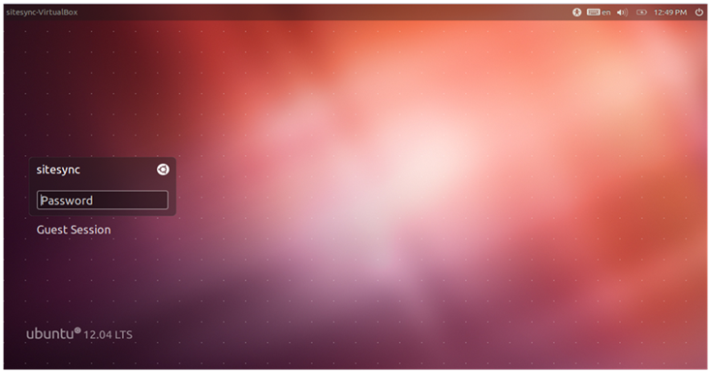

This is user interface mode of Linux. DCU application will run in command line mode. Press Ctrl + Alt + F1 to go on command prompt mode. Following login screen will be displayed on pressing the key sequence.

Ubuntu 12.04.1 LTS sitesync-desktop tty1

Sitesync-desktop login:

Enter user name and password as **sitesync**. On successful login a prompt will be displayed as shown below.

Ubuntu 12.04.1 LTS sitesync-desktop tty1

Sitesync-desktop login: sitesync

Password:

Last login: Mon Apr 7 23:51:38 IST 2014 on tty1

…………

…………

sitesync@sitesync-desktop:~$

To perform any activity you must be in administrative mode. To change the mode execute following command.

sitesync@sitesync-desktop:~$ sudo su

[sudo] password for sitesync:

root@sitesync-desktop:/home/sitesync#

After executing above command Linux will ask for password, enter sitesync as password. After this the prompt will change from **$ to #**.

This ensures that you now have permission to perform administrative actions.

# Installing necessary libraries and DCU application

DCU application requires few important and necessary libraries to be present on Linux. For installation of these necessary libraries following steps are to be followed:

1. Download the **dcusetup** folder from the share folder provided by Maven on Internet.
2. Copy the file to USB drive using Windows 7. Before using the USB drive ensure that the drive is formatted in FAT format.
3. Insert the USB drive to Atom board.
4. Restart the Atom board. And login as explained earlier.
5. Copy the sitesyncdcu.tar from USB drive to /home/sitesync using following commands:

sitesync@sitesync-desktop:~$ sudo su

[sudo] password for sitesync:

root@sitesync-desktop:/home/sitesync#

After executing above command Linux will ask for password, enter sitesync as password. After this the prompt will change from $ to #. This ensures that you now have permission to copy and execute binaries.

root@sitesync-desktop:/home/sitesync# mkdir /media/usb

root@sitesync-desktop:/home/sitesync# mount /dev/sdb1 /media/usb

root@sitesync-desktop:/home/sitesync# cd /media/usb

The above commands will make

1. The subfolder **usb** in **media** folder.
2. Mount the USB driver to **/media/usb** folder
3. Change the current directory to **/media/usb**

In above commands /dev/sdb1 is the USB drive connected.

root@sitesync-desktop://media/usb# cp –rf ./dcusetup /home/sitesync

The above command will copy the folder to **/home/sitesync** folder

1. Enter into the directory **dcusetup** by using command:

root@sitesync-desktop://media/usb# cd /home/sitesync/dcusetup

1. Run the installable using following command:

root@sitesync-desktop:/home/sitesync/dcusetup# ./install.sh

1. As soon as the installable is executed installation process will be visible on the console. Once installation is completed and the prompt is visible then reboot the system by executing following command.

root@sitesync-desktop:/home/sitesync/dcusetup# sudo reboot

1. After successful reboot, login screen will be displayed. Login into the system and verify whether DCU application is running or not. To verify please execute following command:

sitesync@sitesync-desktop:~$ ps –A | grep dcu

1. The above command is to identify whether the DCU application is present in the active running process list or not. If it is present then above command shows DCU process similar to something shown below:

sitesync@sitesync-desktop:~$ ps –A | grep dcu

897 ? 01:13:40 dcu